Production and Logistics Management System (PLM)

Requirements
Req ID | Requirement | Rationale | Source | Feature ID | Block ID
PLM-REQ-01 | The system shall create and schedule production orders for new batter mixing processes | Main responsibility of Order and Schedule subsystem. Ensures production activities are systematically planned and tracked | UC1 | PLM-FEAT-02 | PLM-AF-01
PLM-REQ-02 | The system shall maintain recipe definitions and target parameters used by production stations | Centralizes quality and consistency parameters so batching stations execute uniform formulas | UC1 | PLM-FEAT-05 | PLM-AF-02
PLM-REQ-03 | The system shall initiate production by sending the "Production order and recipe targets" signal to BAT | Also a main responsibility of Order and Schedule subsystem | UC1 | PLM-FEAT-02 | PLM-AF-01
PLM-REQ-04 | The system shall process incoming "Ingredient request and reservation result" signals. | System needs bidirectional communication with BAT | UC1, FC1, FC2 | PLM-FEAT-07 | PLM-AF-03
PLM-REQ-05 | The system shall verify that requested ingredients are in stock and reserve the required quantities. | Prevents by ensuring physical materials are guaranteed before mixing starts | UC1 | PLM-FEAT-07 | PLM-AF-03
PLM-REQ-06 | The system shall enforce the business rule that only organic ingredients may be used. | A requirement if UC1 | UC1 | PLM-FEAT-08 | PLM-AF-03
PLM-REQ-07 | The system shall update warehouse inventory numbers when ingredients are collected. | Maintains a single source of truth for stock levels | UC1 | PLM-FEAT-09 | PLM-AF-03
PLM-REQ-08 | The system shall return a confirmation signal “Ingredient request and reservation result” for a successful reservation. | Confirmation is needed for BAT to proceed with production | UC1 | PLM-FEAT-07 | PLM-AF-03
PLM-REQ-09 | The system shall detect when there is insufficient stock to fulfill a reservation request | Prevents automated systems from initiating batches that cannot be completed | FC1 | PLM-FEAT-10 | PLM-AF-03
PLM-REQ-10 | The system shall return an insufficient stock "Ingredient request and reservation result" signal when a reservation fails | To trigger BAT handling of the insufficient stock protocol | FC1 | PLM-FEAT-10 | PLM-AF-03
PLM-REQ-11 | The system shall hold the active production order if an ingredient reservation fails due to insufficient stock. | Preserves the pending order without deleting it, allowing for fulfillment after restock | FC1 | PLM-FEAT-02 | PLM-AF-01
PLM-REQ-12 | The system shall publish a "Log, warning, error and discard events" signal to notify Logistics of the missing ingredients. | Alerts the Logistics department to deal with the shortage | FC1 | PLM-FEAT-10 | PLM-AF-05
PLM-REQ-13 | The system shall release the held production order only after the required ingredients are restocked and successfully reserved | Ensures production automatically resumes safely without requiring manual order recreation | FC1 | PLM-FEAT-02 | PLM-AF-01
PLM-REQ-14 | The system shall monitor requests to the Warehouse Management System for timeouts. | Prevents network or subsystem failures from hanging the entire production scheduling loop | FC2 | PLM-FEAT-03 | PLM-AF-01
PLM-REQ-15 | The system shall suspend communication with the warehouse during periods of unresponsiveness and automatically restore communication only once the warehouse is confirmed to be responsive. | Protects downstream systems from cascading failures and reduces unnecessary load during outages | FC2 | PLM-FEAT-03 | PLM-AF-01
PLM-REQ-16 | The system shall send an "Ingredient request and reservation result" signal instructing the batching station to continue using already-staged ingredients while warehouse communication is suspended | Maintains operational efficiency by allowing physical processes to continue with local stock during the outage | FC2 | PLM-FEAT-03 | PLM-AF-01
PLM-REQ-17 | The system shall receive the signal "Pallet ready for shipment" from Finishing & Packaging | Operational trigger to transition finished goods from production to outbound logistics | UC16 | PLM-FEAT-12 | PLM-AF-04
PLM-REQ-18 | The system shall assign transport vehicles or slots and coordinate delivery of finished pallets after receiving the ready signal | Prevents factory floor bottlenecks by ensuring finished goods are immediately cleared for dispatch | UC16 | PLM-FEAT-12 | PLM-AF-04

Features
Feature ID | Feature Name | Parent | Type | Requirements
PLM-FEAT-00 | Production and Logistics Management | - | root | -
PLM-FEAT-01 | Order and Scheduling | PLM-FEAT-00 | mandatory | -
PLM-FEAT-02 | Production order creation and holding | PLM-FEAT-01 | mandatory | 01,03,11,13
PLM-FEAT-03 | Warehouse timeout handling | PLM-FEAT-01 | mandatory | 14,15,16
PLM-FEAT-04 | Recipe Management | PLM-FEAT-00 | mandatory | -
PLM-FEAT-05 | Recipe target definition | PLM-FEAT-04 | mandatory | 02
PLM-FEAT-06 | Warehouse and Inventory | PLM-FEAT-00 | mandatory | -
PLM-FEAT-07 | Ingredient reservation processing | PLM-FEAT-06 | mandatory | 04,05,08
PLM-FEAT-08 | Organic ingredient verification | PLM-FEAT-06 | mandatory | 06
PLM-FEAT-09 | Inventory level updating | PLM-FEAT-06 | mandatory | 07
PLM-FEAT-10 | Insufficient stock handling and reporting | PLM-FEAT-06 | mandatory | 09,10,12
PLM-FEAT-11 | Transport and Shipment | PLM-FEAT-00 | mandatory | -
PLM-FEAT-12 | Pallet received and sending coordination | PLM-FEAT-11 | mandatory | 17,18

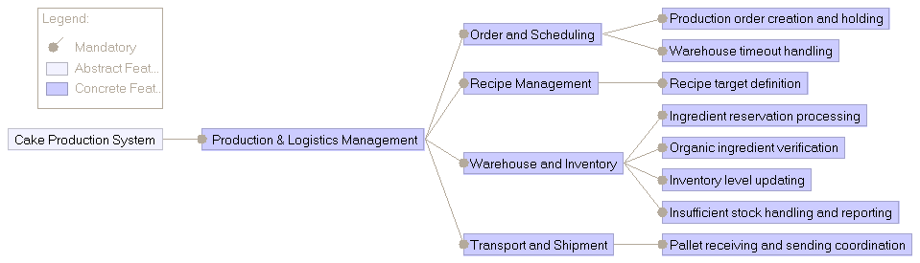
Feature model diagram

Analysis blocks

Analysis functions

ID | Analysis Func | Responsibility | Inputs | Outputs | Devices | Features | Requirements
PLM-AF-01 | Order and Scheduling Manager | Creates and schedules production orders; holds them when out of stock handles timeouts when warehouse is unresponsive; gateway for BAT messages | Ingredient request and reservation result (External from BAT)  Recipe target data (Internal from AF-02)  Stock reservation status (Internal from AF-03) | Production order and recipe targets  (External to BAT)  Ingredient request and reservation result  (External to BAT);  Stock reservation check (Internal to AF-03) | - | 01,02,03 | 01,03,11,13,14  15,16,
PLM-AF-02 | Recipe Manager | Manages internal recipes and supplies them to AF-01 | Recipe updates (Business layer) | Recipe target data (Internal to AF-01) | - | 04,05 | 02
PLM-AF-03 | Warehouse and Inventory Manager | Inventory logic; reserves, updates and checks stock; | Stock reservation check (Internal from AF-01); Ingredient withdrawal confirmation (from FD-01) | Stock reservation status (Internal to AF-01); Stockout notification (Internal to AF-01/AF-05) | FD-01 | 06,07,  08,09,  10 | 04,05,08,06,07  09,10
PLM-AF-04 | Transport and Shipment Planner | Receives pallet ready signals from FIN and coordinates shipping | Pallet ready for shipment (External from FIN) | Shipment dispatch order | FD-02,  03 | 11,12 | 17,18
PLM-AF-05 | Event Reporting | Publishes log, warning, error and discard events to MON | Internal health/error states (from all AFs) | Log, warning, error and discard events (External to MON) | - | Cross cutting | 12

Functional devices
ID | Device Name | Kind | Used By | Source (UC/FC) | Responsibility
PLM-FD-01 | Warehouse Storage Equipment | Actuator | PLM-AF-03 | UC1 | Physical retrieval equipment; sends ingredient withdrawal confirmation to AF-03.
PLM-FD-02 | Delivery Warehouse | Storage Area | PLM-AF-04 | UC16 | Holding bay where finished, wrapped pallets wait for transport assignment.
PLM-FD-03 | Transport Vehicles | Actuator / Logistics | PLM-AF-04 | UC16 | Physical shipping trucks/forklifts used to send transport ready pallets.

External ports
Signal name | Direction | External System | Connected Internal Block
Production order and recipe targets | out | BAT | PLM-AF-01
Ingredient request and reservation result | In-out | BAT | PLM-AF-01
Pallet ready for shipment | in | FIN | PLM-AF-04
Log, warning, error and discard events | out | MON | PLM-AF-05

Internal ports
Signal name | Block | Target Block
Recipe target data | PLM-AF-02 | PLM-AF-01
Stock reservation check | PLM-AF-01 | PLM-AF-03
Withdrawal confirmation | PLM-AF-03 | PLM-FD-01
Fleet dispatch commands | PLM-AF-04 | PLM-FD-03
Delivery warehouse coordination | PLM-AF-04 | PLM-FD-02

Block definition diagram
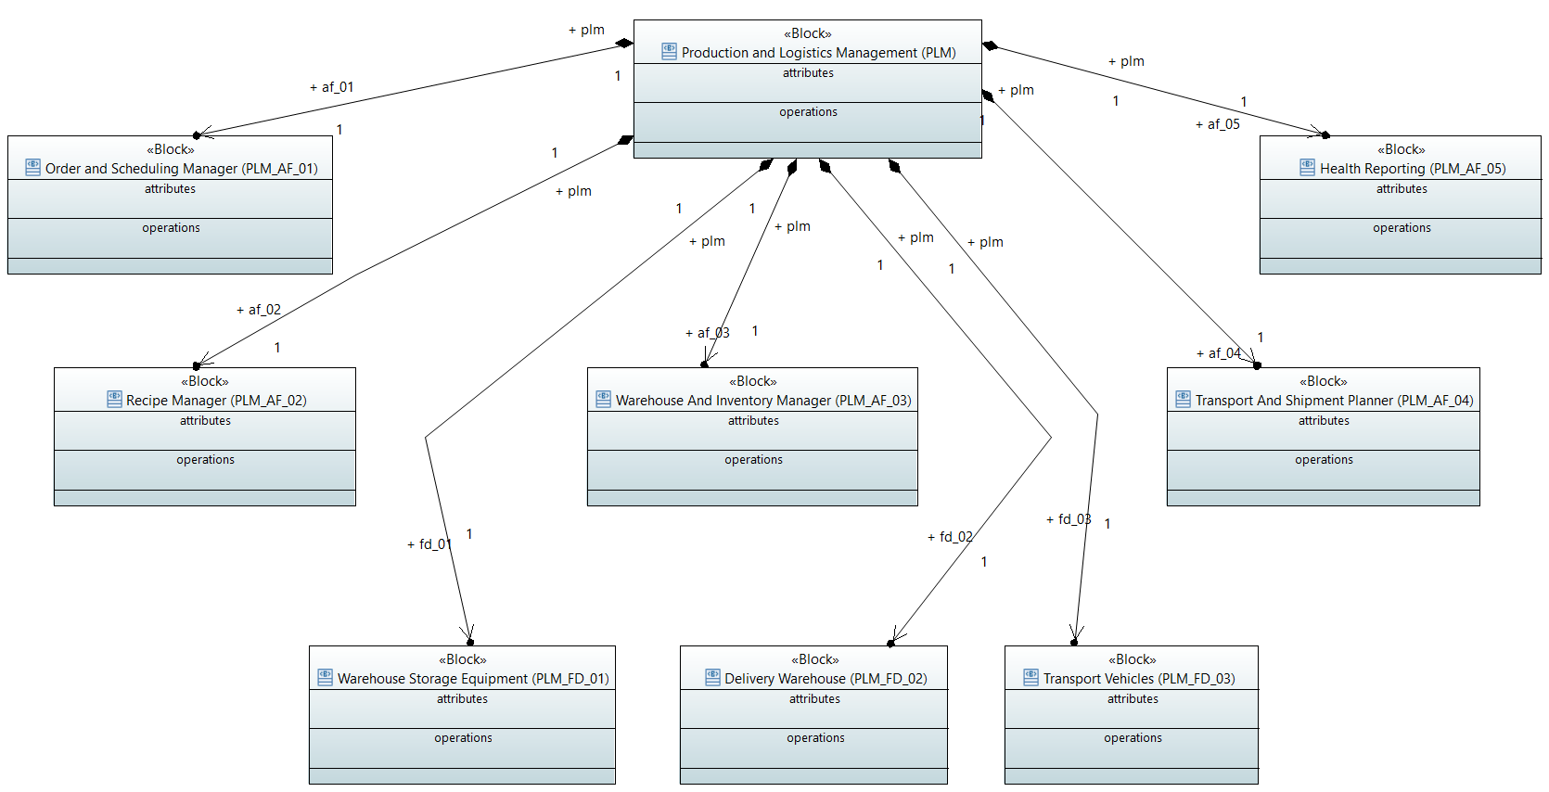

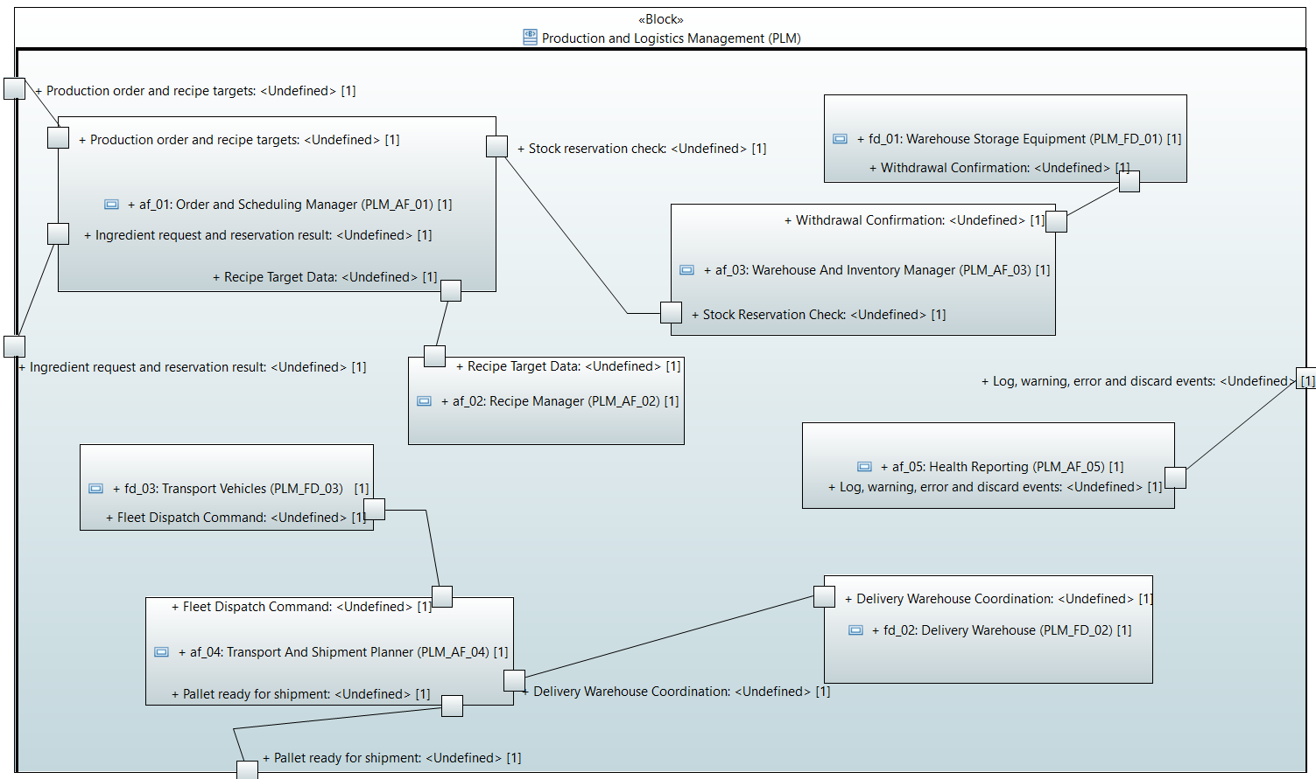
Internal block diagram

